Installation of PHP Serial in Laragon
Step-by-Step Installation via Terminal
- Open Laragon's Terminal:
  - Right-click the Laragon icon in the system tray (bottom-right taskbar) and select Terminal (or press Ctrl + T if the menu is open).
  - This opens a command prompt (CMD) or PowerShell directly in your Laragon environment, with paths to PHP and Composer already set (e.g., C:\laragon\bin\php and C:\laragon\bin\composer).
- Navigate to Your Project Directory:
  - In the terminal, change to your project's root folder (where composer.json will live or already exists):
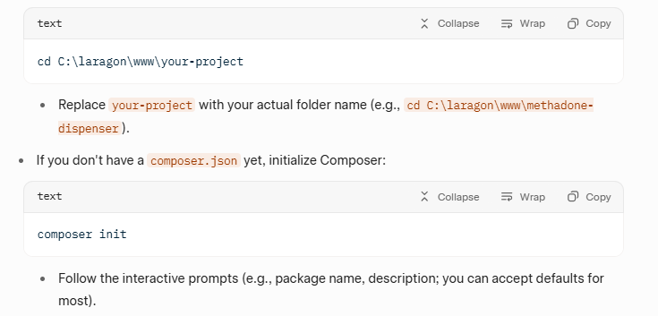
Bash
cd C:\laragon\www\iorpms
- Replace your-project with your actual folder name (e.g., cd C:\laragon\www\methadone-dispenser).
Bash If you don't have a composer.json yet, initialize Composer:
text
composer init
- Install the php-serial Package:
- Run the following command to add gazsp/php-serial as a dependency:
Bash
composer require gazsp/php-serial
This will:
- Download and install the package and its dependencies into a vendor/ folder.
- Update your composer.json and composer.lock files.
- If prompted, confirm any interactive questions (e.g., yes to add as a requirement).
Expected output: Something like "Using version ^0.0.4 for gazsp/php-serial" followed by "Writing lock file" and "Generating autoload files."

- Verify the Installation:
- Check if the package is listed:
bash
composer show gazsp/php-serial
  - This should display details like version 0.0.4 and description.
- Test autoloading in a PHP file (e.g., create test.php in your project):
Php
<?php
require_once 'vendor/autoload.php';
use PhpSerial; // From the php-serial library
echo "php-serial installed successfully!";
$serial = new PhpSerial();
echo "\nSerial class loaded: " . (class_exists('PhpSerial') ? 'Yes' : 'No');
?>
Run it: php test.php. It should output success messages.
- Use It in Your Code:
  - In your PHP scripts (e.g., MasterflexPump.php), include the autoloader:
php
require_once 'vendor/autoload.php';
use PhpSerial;
  - Now you can instantiate new PhpSerial() for serial port operations.
Troubleshooting
- Command Not Found (e.g., 'composer' is not recognized):
  - Ensure Laragon's bin paths are in your system PATH: Go to Laragon menu → Tools → Add Laragon to PATH (restart terminal after).
  - Or use full paths: C:\laragon\bin\composer\composer.phar require gazsp/php-serial.
  - Verify Composer version: composer -V (should show 2.x).
- Permission Errors or Antivirus Blocks:
  - Run the terminal as Administrator (right-click Laragon → Run as admin).
  - Temporarily disable antivirus if it flags Composer downloads.
- SSL/Proxy Issues During Download:
  - If behind a proxy: composer config -g repo.packagist composer https://packagist.org (or add --no-scripts to the require command).
  - For SSL errors: composer config -g secure-http false (use cautiously).
- Package Not Found:
  - Confirm the package name: It's gazsp/php-serial (from GitHub). If outdated, check Packagist.org for alternatives like m2mtech/php-serial.
- Laragon-Specific Issues:
  - If using a specific PHP version, switch via Laragon menu → PHP → Version (e.g., PHP 8.1), then restart services.
  - For global packages (rarely needed): composer global require gazsp/php-serial, but project-local is recommended.
This process should take 2-5 minutes. Once installed, you can integrate it into your pump code as discussed earlier (e.g., updating MasterflexPump.php to use PhpSerial). If you encounter errors, share the exact output for more help!

